LAB1 BASH

Using sed utility

1- Display the lines that contain the word “lp” in /etc/passwd file.

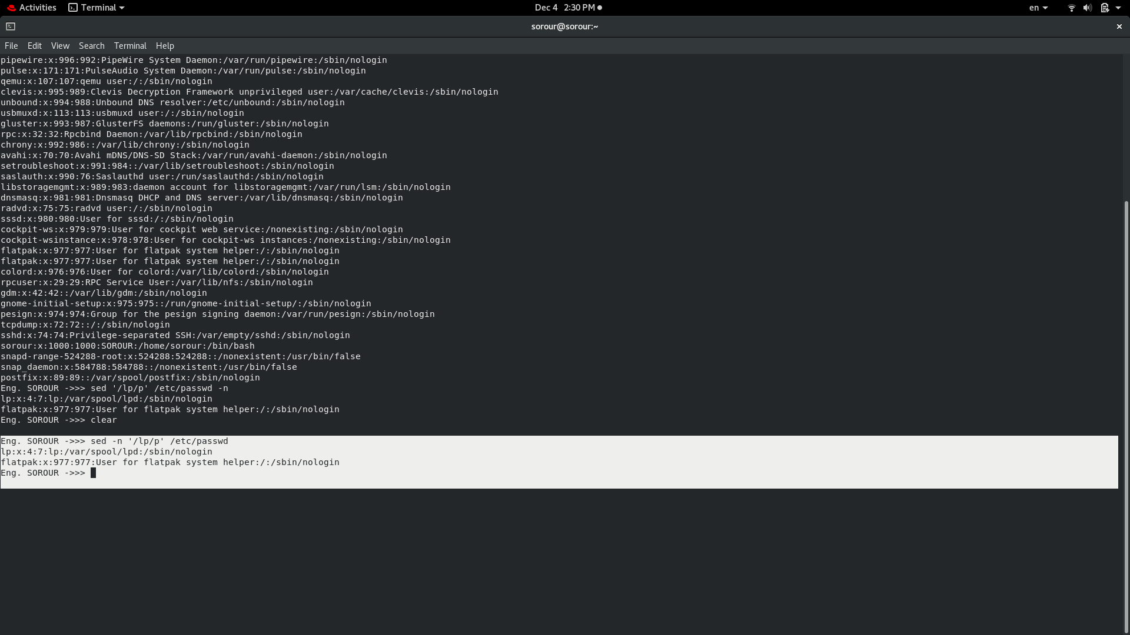

2- Display /etc/passwd file except the third line.

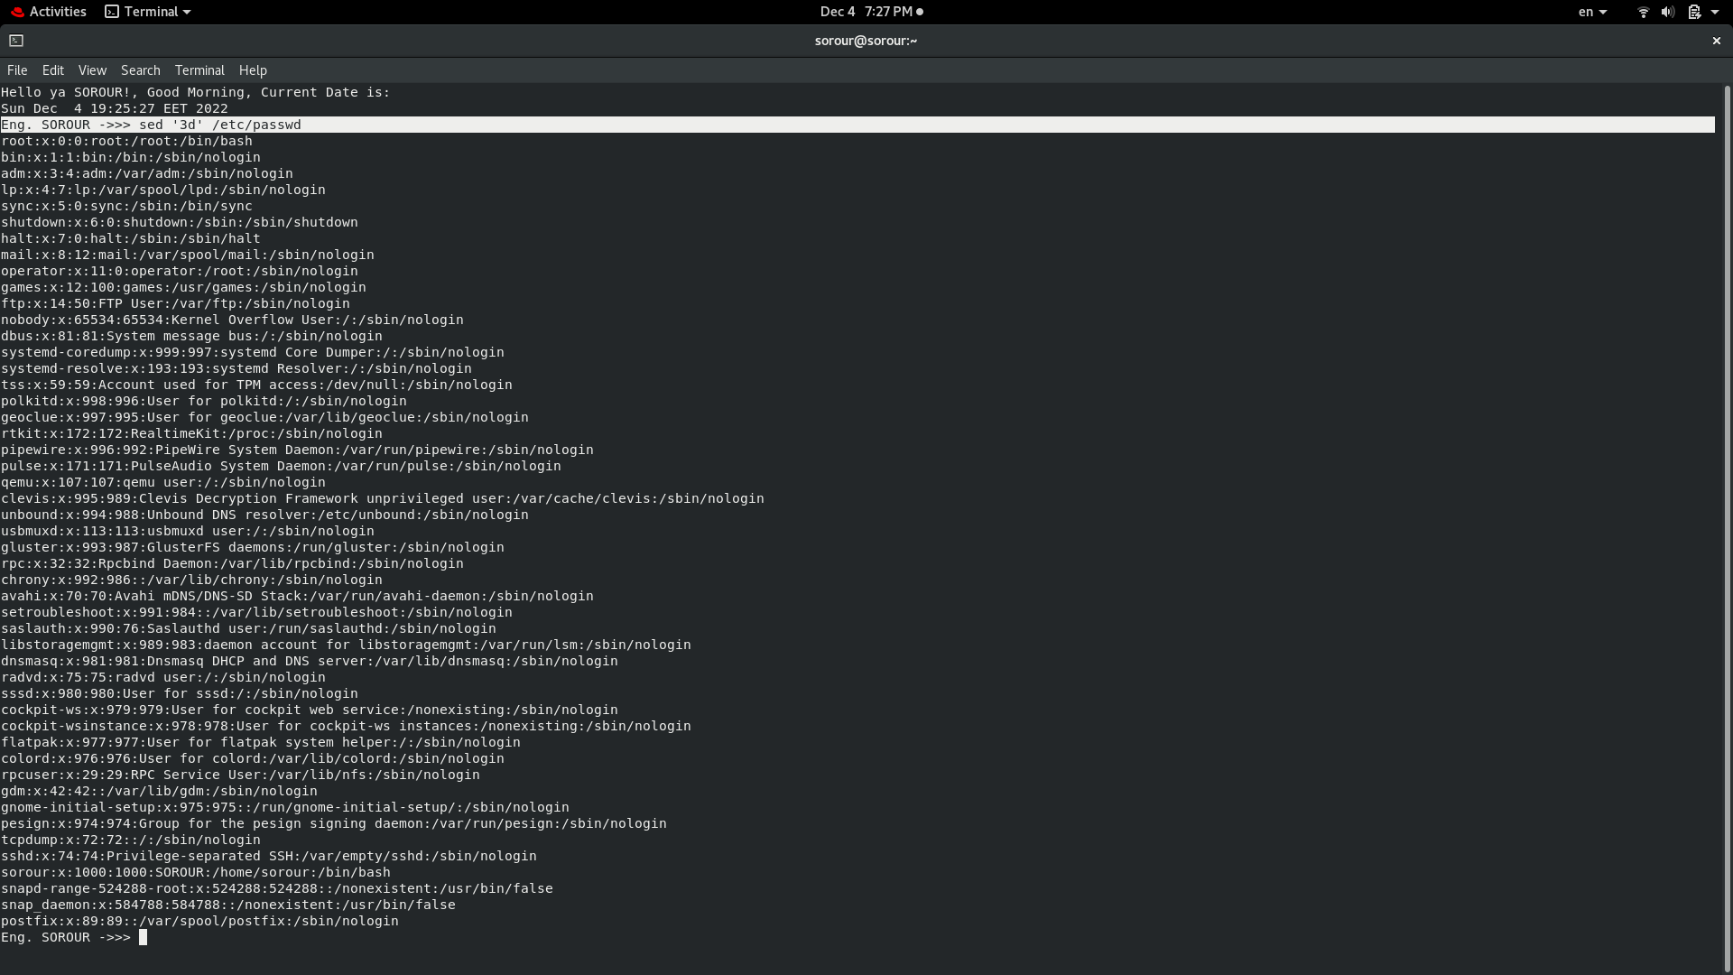

3- Display /etc/passwd file except the last line.

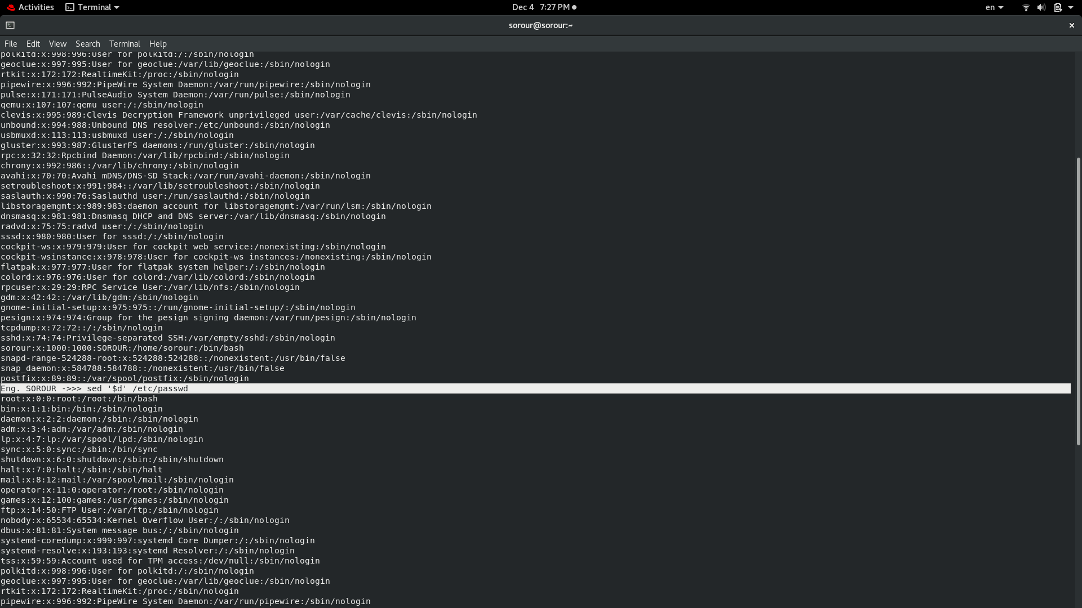

4- Display /etc/passwd file except the lines that contain the word “lp”.

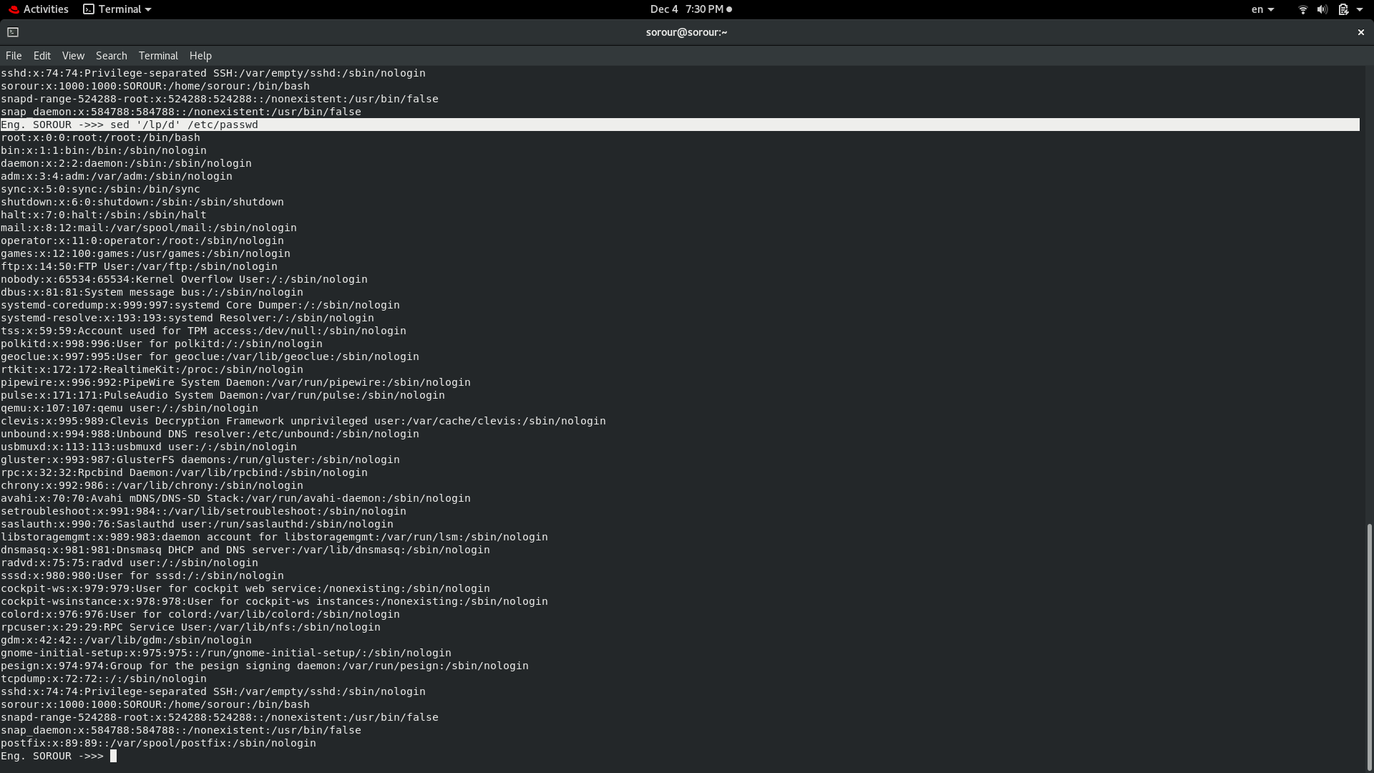

5- Substitute all the words that contain “lp” with “mylp” in /etc/passwd file.

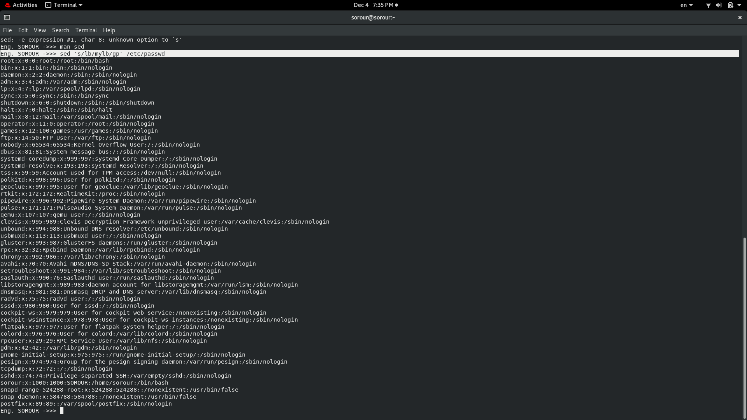

Using awk utility

1- Print full name (comment) of all users in the system.

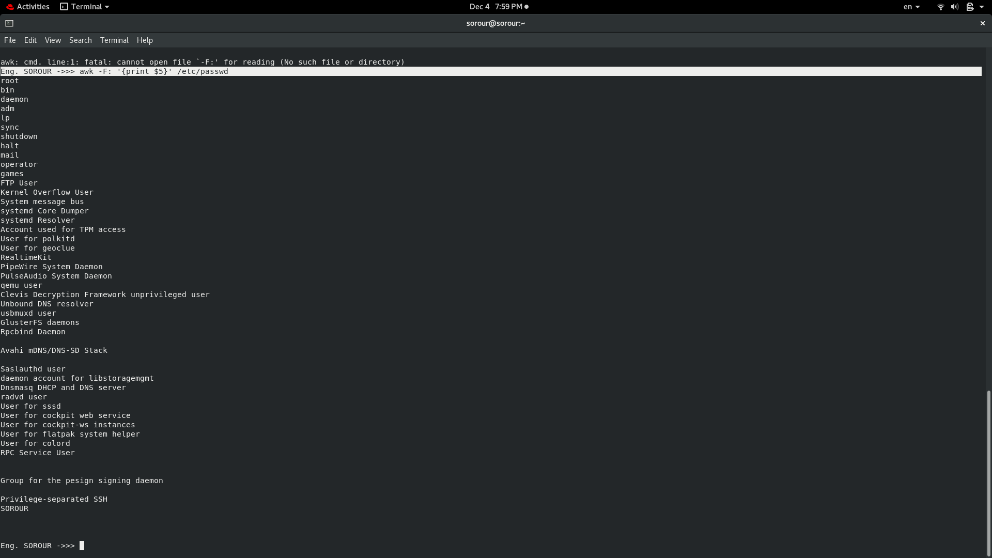

2- Print login, full name (comment) and home directory of all users.( Print each line preceded

by a line number)

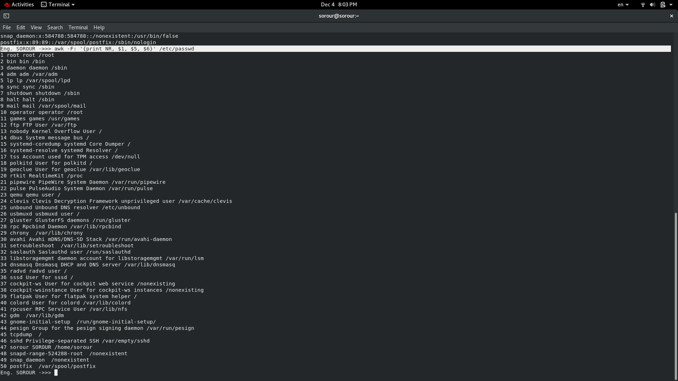

3- Print login, uid and full name (comment) of those uid is greater than 500

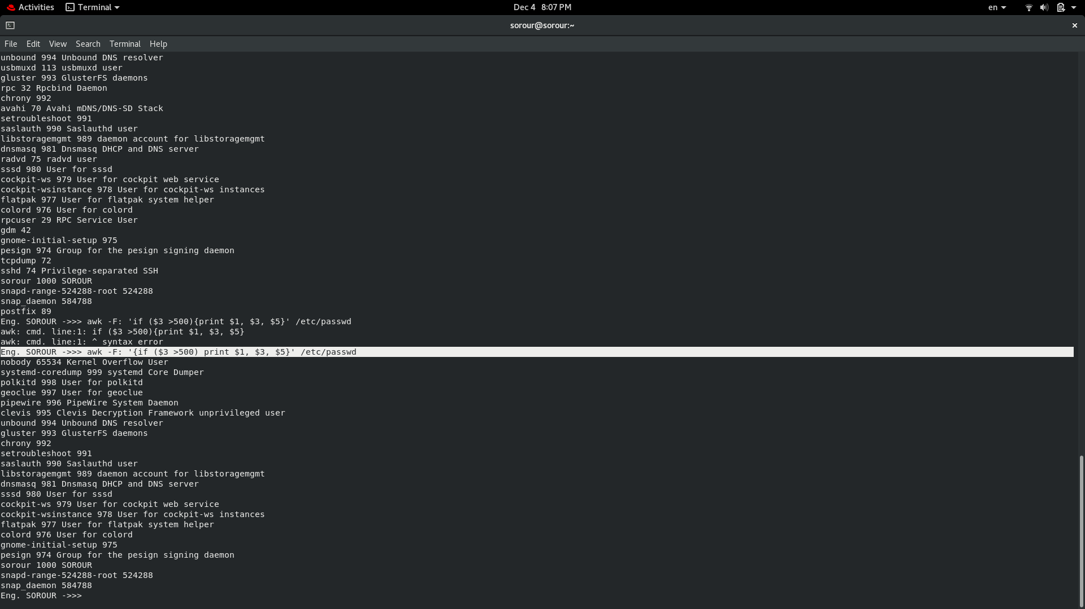

4- Print login, uid and full name (comment) of those uid is exactly 500

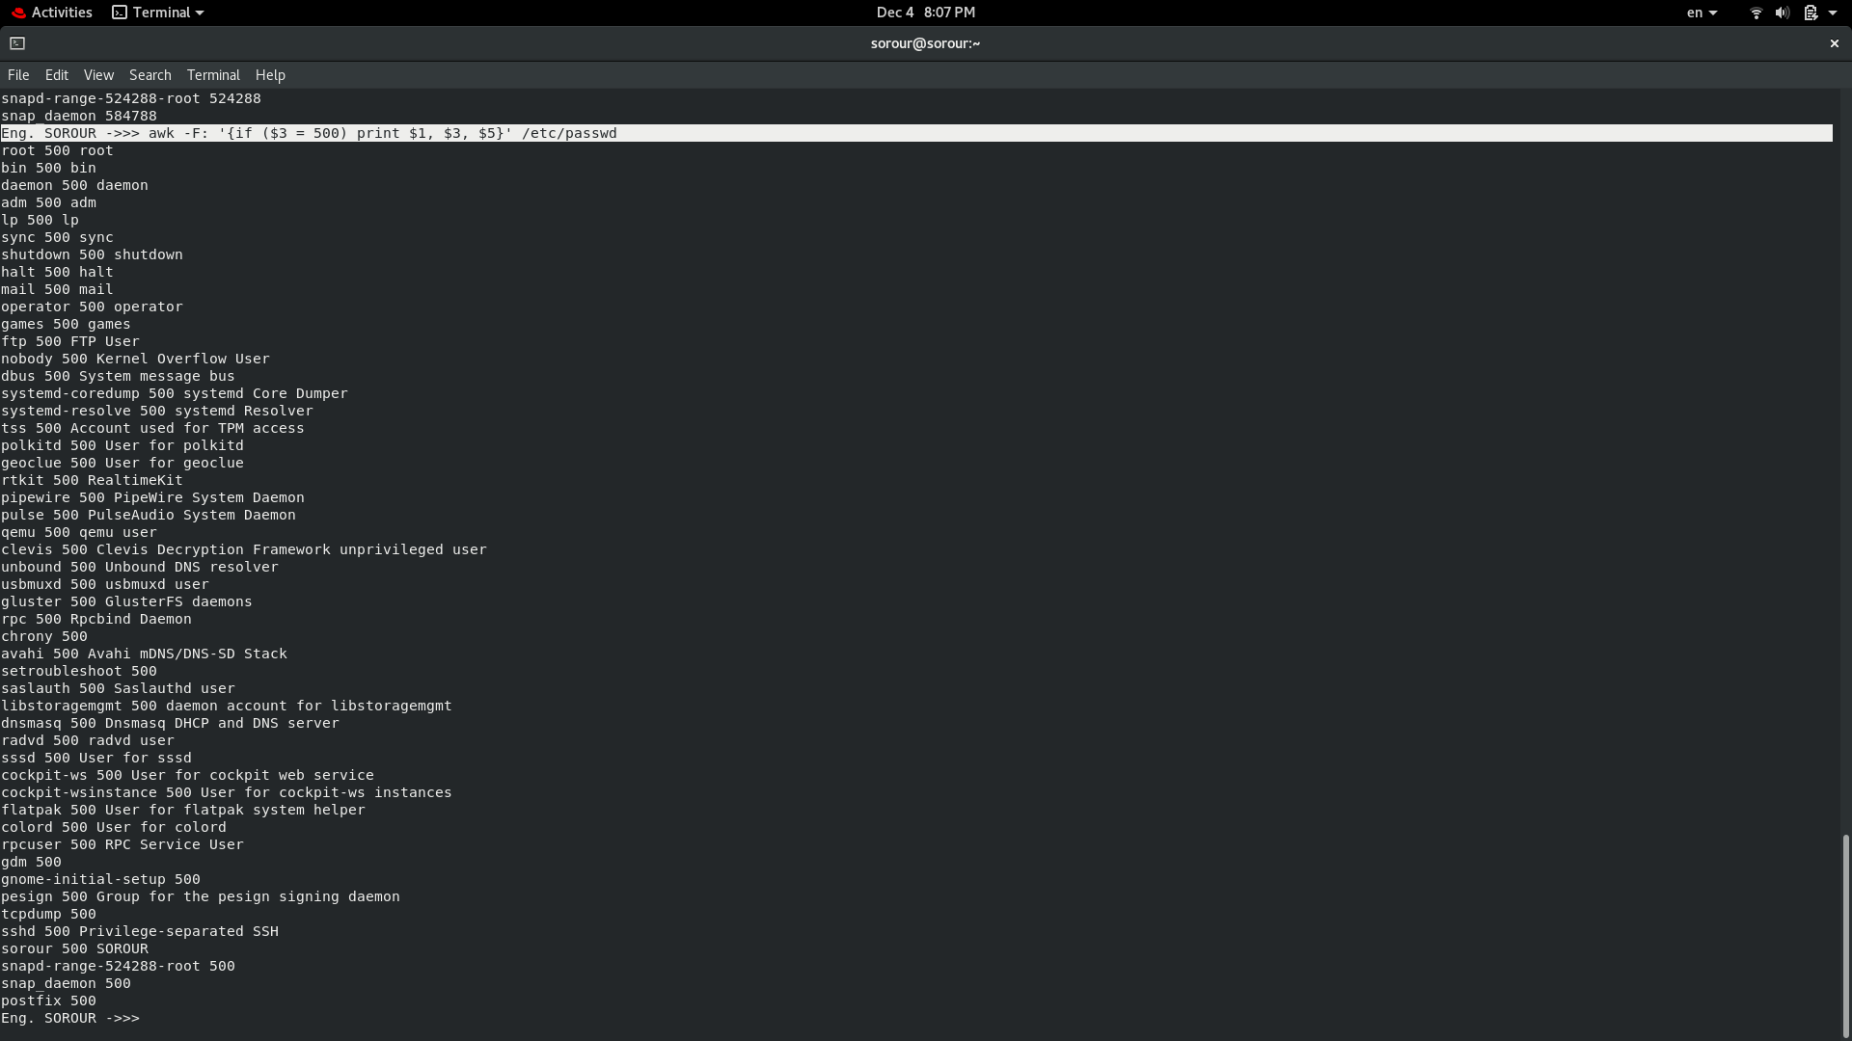

5- Print line from 5 to 15 from /etc/passwd

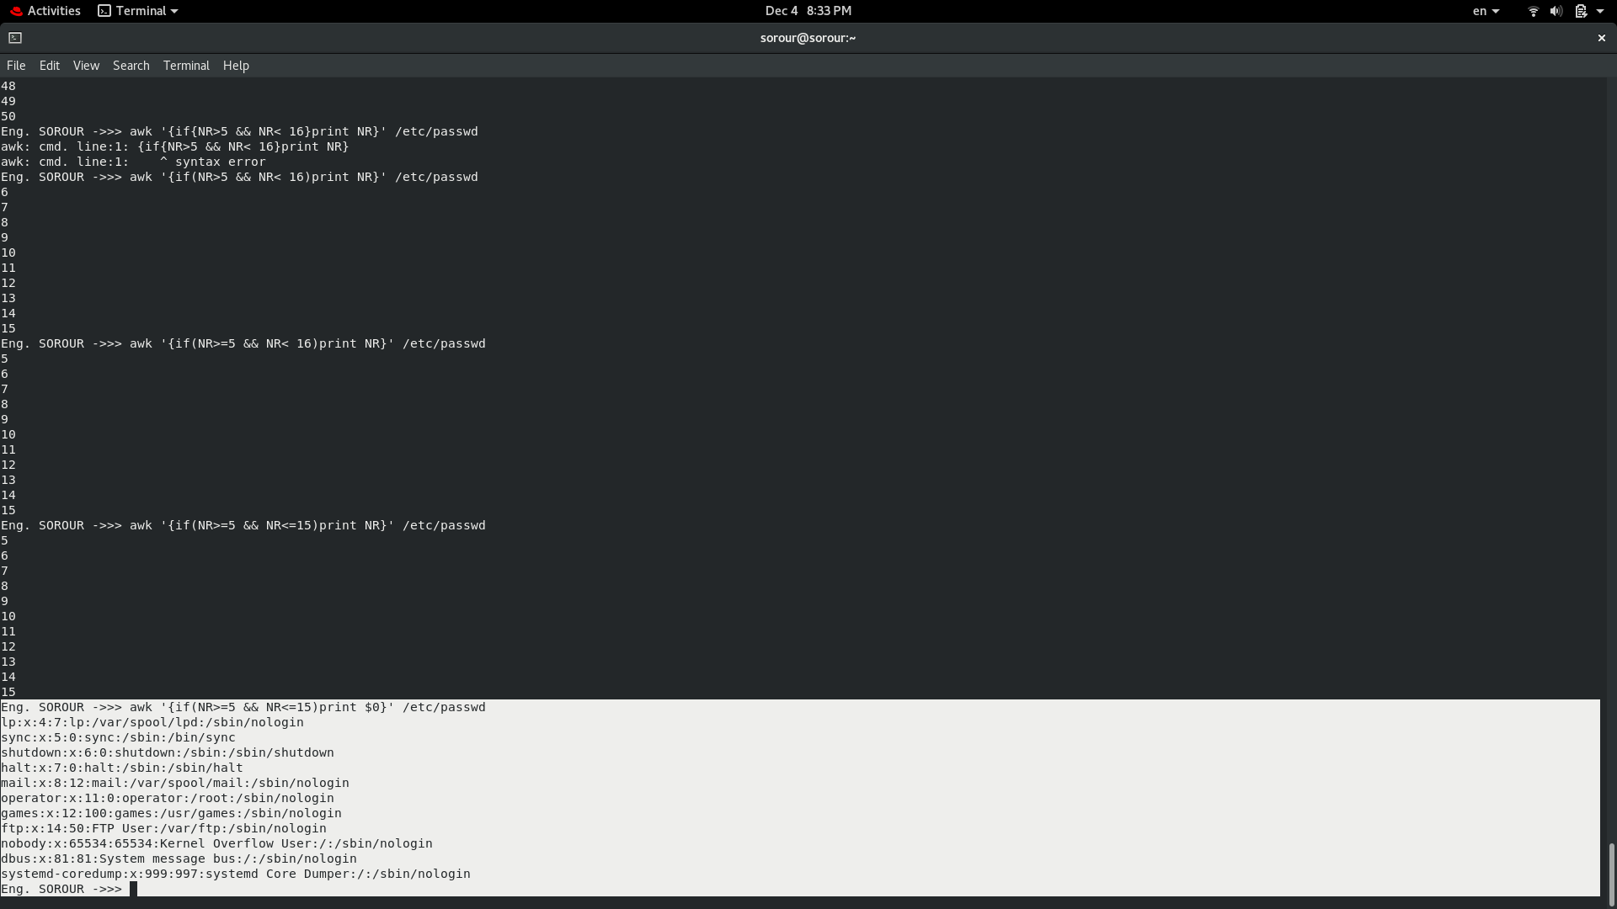6- Change lp to mylp

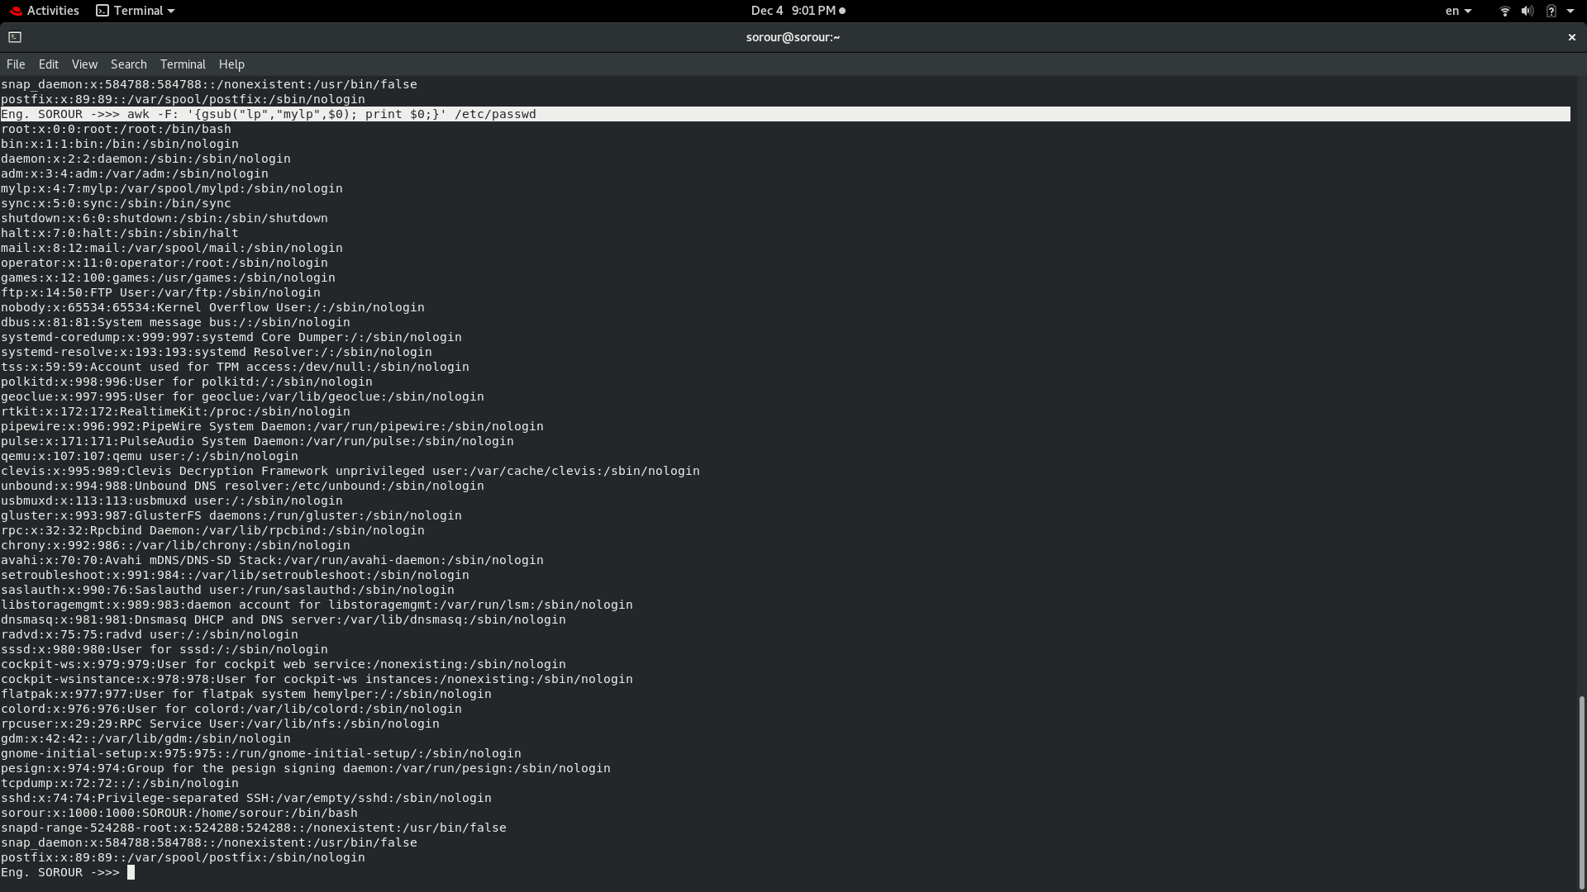

7- Print all information about greatest uid.

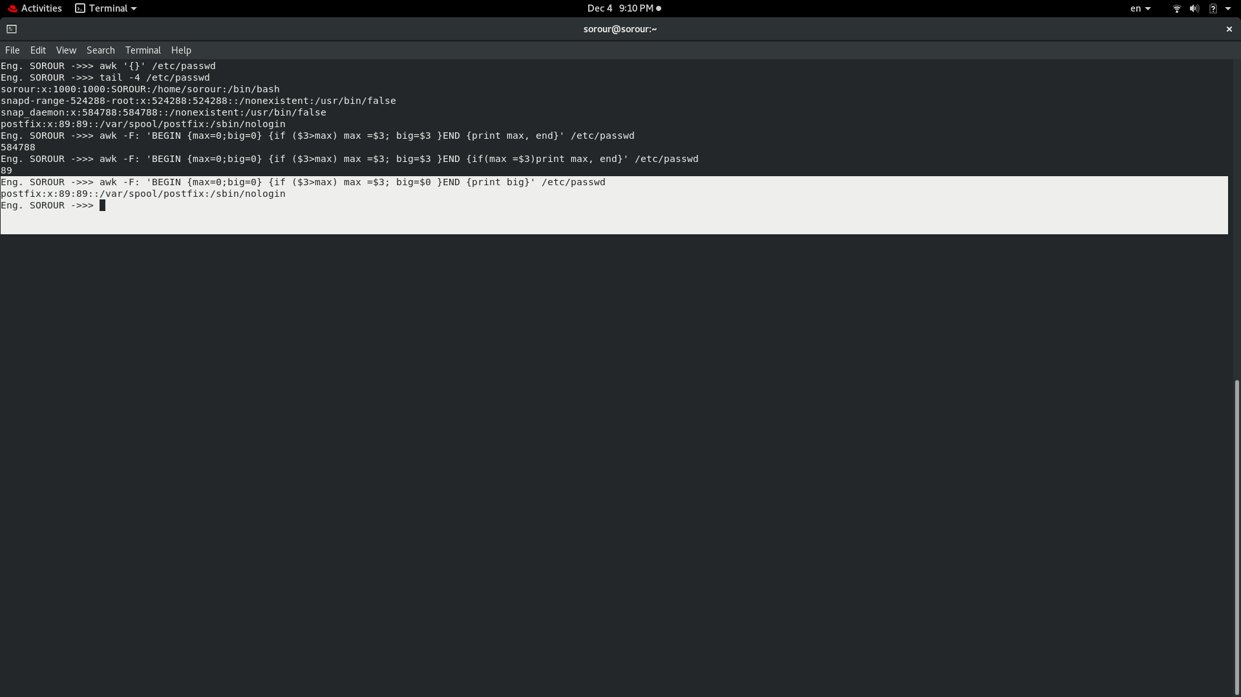

8- Get the sum of all accounts id’s.

